**WEEK 5**

**NAME OF SCHOOL:**

**Topic: Materials for concrete (contd.).**

**Class: SS2**

**Date:**

**Duration: 80 minutes**

**Specific instructional objective: At the end of the lesson, student should be able to**

* **List cement manufacturing processes**
* **Explain components of cement**
* **Describe the uses of cement**
* **Explain properties of cements and its roles in concretes (binder)**

**Entry Behaviour: students have seen bags of cement before**

**Instructional Materials: Chalk board, text book, charts, pictures, cement**

**Instructional Procedure:**

|  |  |  |  |
| --- | --- | --- | --- |
| **Step** | **Contents** | **Teacher’s activity** | **Student’s activity** |
| **1** | **Definition of cement** | **Define cement: Cement is the chemical material that bonds the aggregates together to form a solid material.** | **Listen, take notes and ask questions** |
| **2** | **Components of cement** | **Explain components of cements** |  |
| **3** | **Uses of cement** | **Describe where it is used** |  |
| **4** | **Properties of cement** | **Explain properties of cement** |  |
| **4** | **Evaluation** | **Teacher ask questions , and allowed the students to answer one after the other**   * **List and explain the component of cement** * **Explain two properties of cement** | **Students respond to the questions and may ask their own questions** |
| **5** | **Assignment** | **Teacher asks the students to draw a neat diagram showing ground floor and label all the important part.** |  |

**CONCRETE MATERIALS:**

**CEMENT**

**Cement is the chemical material that bonds the aggregates together to form a solid material.**

**There are many types of cement available for construction work but the commonly available type is the ORDINARY PORTLAND CEMENT [OPC] is manufactured from chalk and clay.**

**The process of manufacturing consist of the lime stone and clay mixing and grinding them in a special wet or dry mill, burning the mixture and finally grinding in the dry mill and bagging or storing into silos others are:**

**{1}Rapid Harding Portland cement: The cement powder is more finely than OPC. The effects of the finer ground are that the constituent of the cement powered reacts more quickly with water. It also develops strength more rapidly. It is used where greater strength is needed in construction.**

**{2} Extra Rapid Hardening Portland Cement: The rate of hardened of this cement is increased as adding an accelerator e.g. Calcium Chloride to harden the cement.**

**{3} Low Heat Portland Cement: This cement is of modified composition to give a low rate of heat solution. It’s made for mass concrete works in dams and other longer construction.**

**{4} Sulphate Resisting Portland Cement: This is modified Portland cement with improved resistance to the chemical attack by sulphate. It can cause soften and considerable expansion of cement based materials.**

**{5} White Portland Cement: This is used to produce white cement finishes; it’s mainly used for the surface of exposed concrete and for cement rendering. Pigment may be added the cement to provide paste colour.**

**{6} Blast Furnace Portland Cement: This cement developed heat more slowly than ordinary Portland cement and is used also for mass concrete work as allow heat cement. It has resistance to the destructive effect of sulphates and is commonly used in marine work.**

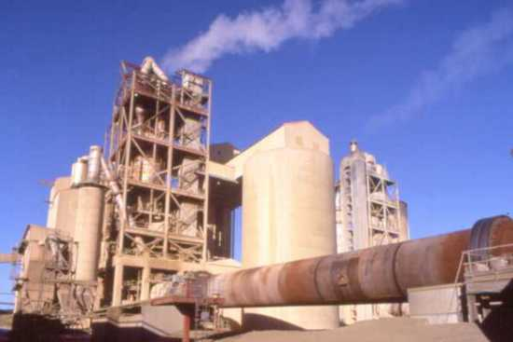

### Summary of production process

**Cement is typically made from limestone and clay or shale. These raw materials are extracted from the quarry crushed to a very fine powder and then blended in the correct proportions.**

**This blended raw material is called the 'raw feed' or 'kiln feed' and is heated in a rotary kiln where it reaches a temperature of about 1400 C to 1500 C. In its simplest form, the rotary kiln is a tube up to 200 metres long and perhaps 6 metres in diameter, with a long flame at one end. The raw feed enters the kiln at the cool end and gradually passes down to the hot end, then falls out of the kiln and cools down.**

**The material formed in the kiln is described as 'clinker' and is typically composed of rounded nodules between 1mm and 25mm across.**

**After cooling, the clinker may be stored temporarily in a clinker store, or it may pass directly to the cement mill.**

**the cement mill grinds the clinker to a fine powder. A small amount of gypsum - a form of calcium sulphate - is normally ground up with the clinker. The gypsum controls the setting properties of the cement when water is added.  
  
  
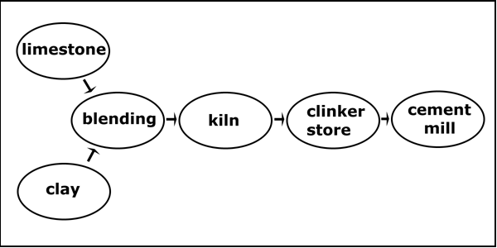  
The basic components of the cement production process.**

**The following pages (see links below) have more detail on each of the different stages of cement production. Also, see the '**[**Clinker**](http://www.understanding-cement.com/clinker.html)**' pages for information on raw materials, the chemical reactions in the kiln, cement clinker and cement chemistry.**

**CONCRETING OPERATIONS;**

**{a}Batching: Is the system by which concrete material are proportioned in the ratio of the mix. It can be carried out by {i} weight and {ii} volume.**

**Batching by weight is carried out by using weighting machine and batching by volume is carried out by using gauge box, head pan, wheel barrows est.**

**{b} Mixing: Is the through exercise carried out in order to produce concrete of uniform consistency. It can be done by: {i} Hand {ii} Machine {mixing machine}**

**{c} Transporting concrete: This is the system by which mixed concrete is moved from the point of mix to the point of placing on site. The method to be used depend on the type of job, nature of the site, height of which concrete is to be placed and case of transporting the concrete.**

**The method includes:**

1. **Manual transportation: Using of head pan, bucket, wheel barrow and other containers.**

**ii) By mechanical means e.g. dumpers, crane belt, conveyor, pumps, powered barrow, twist fork-lifts, trucks mixer or mobile dumper.**

**[d] Placing; this is done by putting the concrete in position. These include casting of concrete into beams, columns slabs, foundation etc. Concrete must be placed before 30 minutes after mixing.**

**{e} Compaction: is done to reduce voids or air pockets in the concrete, it’s done, during placement by manual means or by mechanical means.**

**There are two method of compaction**

1. **Hand compaction: this is done by using wood or metal rammers to ram the concrete down to achieve a dense hard concrete**
2. **MACHINE COMPACTION: In job of importance machine vibrators are used to compact or vibrate concrete, there are two types of concrete vibrators.**
3. **Internal vibrators {poker} or immersion vibrators. They are inserted into the concrete directly.**
4. **External vibrator- they are clamped to the form-work during vibration.**

**{f} Curing: After placement, for the concrete to gain maximum strength it need water therefore curing is the operation of providing moisture and favourable temperature to allow for increase in strength, durable and resistant. Curing prevent evaporation of water from concrete**

**Method of curing:**

1. **Covering the surface of the concrete with wet sand or saw dust**
2. **Covering with wet sacks/ blankets**
3. **Covering with water proof sheets.**
4. **Curing chemical should be used after placement**
5. **Cover the concrete with non-absolvent materials such as plastics**
6. **Sprinkling/pouring water daily on the concrete**

**Method of transporting fresh concrete with a wheel barrow:**

* **Boards and plank are lay along the way from the place of mix to the part of placing**
* **The internal wheel barrow is wet with water**
* **Fill the wheel barrow with the concrete**
* **Wheel the concrete over the boards**
* **Ensure that the chute is wetted before pouring concrete**
* **Deposit the concrete into the chute**
* **Hovel the concrete into the foundation trench**

**TYPES OF CONCRETE**

1. **Mass concrete: Mass concrete is a concrete without reinforcement. It is strong in compression and weak in tension.**
2. **Reinforced concrete: It is a concrete with reinforcement bars to cater for the weakness in tension of mass concrete**

**TYPES OF BARS: Bars used are mild or plain bars and high tensile or twisted bars**

**High tensile bars are stronger than mild bars; hence they are used for main reinforcement while plain bars are used as secondary reinforcement.**

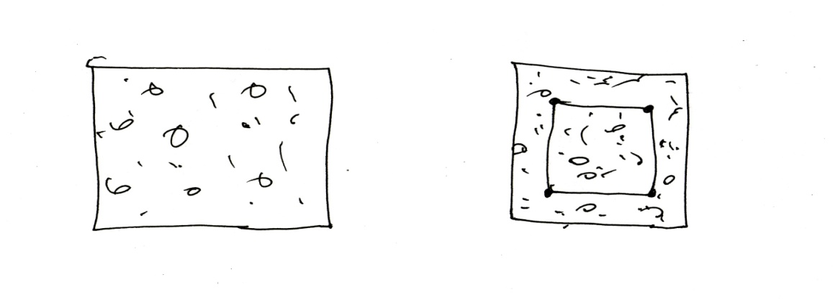**Section thro’ mass concrete section thro’ reinforced concrete**

1. **In-situ concrete: concrete that is casted in the place where it is needed e.g. reinforced concrete beam, lintel, pillars & column and foundation in building**
2. **Precast concrete: This is a concrete prepared in a factory or workshop and transported or carried to a place of placement or needed e.g. concrete for fabricated buildings, fly over’s in roads construction, concrete electrical poles, covets for roads, drainage in road construction**

**Merit of precast concrete:**

1. **It is stronger than in-situ concrete**
2. **It is properly cured under factory condition**
3. **It does not crack easily**
4. **They are easily transported**

**Demerits:**

1. **It is very costly to produce because of the condition of preparation**
2. **It needs experienced skilled workers**
3. **It requires long time for production**
4. **It requires transportation to the point of placing.**

**Merits of In-situ concrete {concrete cast in the site}**

1. **It is cheap or not costly to produce**
2. **It does not require skilled labourers**
3. **It is easily cast in the site**
4. **It does not require transportation.**

**Demerits:**

1. **It is not strong like precast concrete**
2. **It is not cured in an ideal condition**
3. **They are produced in large span**
4. **In-situ concrete are subjected by shares { little cracks}**

**PRESTRESSED CONCRETE:**

**Prestressed concrete is a concrete where high tensile wires or strands are used instead of steel to produce suitable compressive stress in the concretes. Prestressed concrete is permanently under compression and free from cracks under loading**

**There are two methods of prestressing concrete**

1. **Pre-tensioning or long-live system: In this method the wire are stressed first, the concrete cast, the concrete is adhered to set and hardened sufficiently and the wires are cut, The concrete is vibrated with mechanical means and set out for curing**
2. **Post- tensioning: The concrete is cast first with dutch or hole provided to permit the passage of steel wires and stressed the dutch holes are granted with cement paste for the wires to bind with the concrete.**
3. **The following methods are adopted for compacting the concrete:**
   1. **Hand Compaction**
      1. **Rodding**
      2. **Ramming**
      3. **Tamping**
   2. **Compaction by Vibration**
      1. **Internal vibrator (Needle vibrator)**
      2. **Formwork vibrator (External vibrator)**
      3. **Table vibrator**
      4. **Platform vibrator**
      5. **Surface vibrator (Screed vibrator)**
      6. **Vibratory Roller**
   3. **Compaction by Pressure and Jolting**
   4. **Compaction by Spinning.**

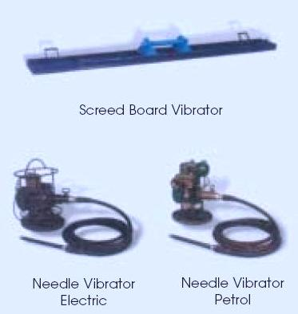 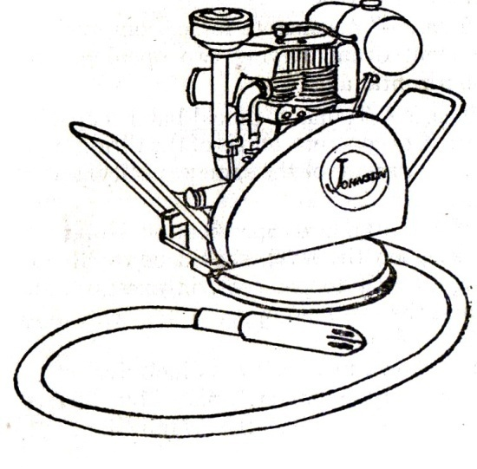

**Safety precaution and personal protection**

* **The site must be neat avoid wood on the ground**
* **Qualifies hand should be available**
* **Care use of cement and its products**
* **Mix concrete well to avoid segregation**
* **Protect skin from cement and cement mixtures, workers should wear alkali resistant gloves**
* **Coveralls with long sleeves and full length trousers ( pull sleeves down over gloves and tuck pants inside boots and duct-tape at the top to keep mortar and concrete out)**
* **Water proof boots high enough to prevent concrete from flowing in when workers must stand in fresh concrete**
* **Suitable respiratory protective equipment such as a P,N or R95 respiratory where cement dust can’t be avoided**
* **Suitable eye protective where mixing, pouring, or other activities may endanger eyes (minimum safety glasses with side shields or goggles) wide extremely dusty conditions light-falling inverted lenses when handling cement or cement products.**

**Hazardous effect of materials**

1. **Cement can cause ill health by skin contact, eyes contact or inhalation**
2. **Severe cause often occur when personal protective clothing or equipment is worn out**
3. **Cement dust released during bag dumping or concrete cutting can also irritate the skin**
4. **Moisture from sweat or wet clothing reacts with the cement dust to form a caustic solution**
5. **Allergic skin reaction**
6. **Exposure to airborne dust may cause immediate or delayed irritation of the eyes**
7. **Inhalation high level of dust may occur when workers empty bags of cement, in the short term, such exposure irritate the nose and throat and causes chocking and difficult breathing**

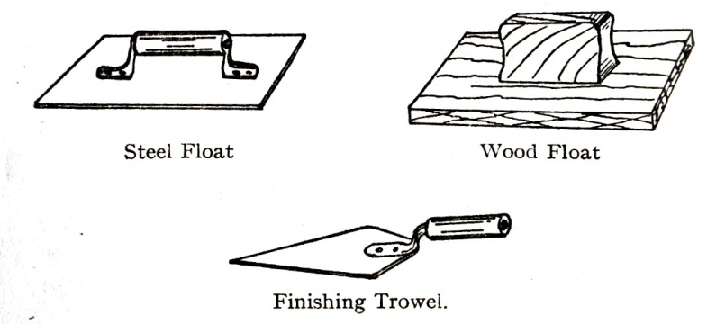

**TOPIC: TEST ON AGREGATE**

1. **SAND TEST: The sand used for making concrete must be clean, coarse and well graded**

**The source of sand used for making good concrete is from flowing river {clean & sharp sand}. Sea sand, flood sand and sand dug from the ground contains salt, clay salt, vegetable matters that may affect the chemical reaction of the concrete**

**TEST ON SAND**

1. **Hand test: This is carried out by rubbing the sand on your two palms. If your palms are stained, the sand contains dust and not fit for good concrete work {not clean} it is a field test.**
2. **Silt test: Is a laboratory test to determine silts on sand. AQ The test is carried out by using a glass jar. The glass jar is filled half with sand and covered with clean water. The mixture is thoroughly shaken and allowed to settle for twelve hours. The top of the glass jar is covered to prevent dust or dirty entering the jar. If the thickness of the silts or volume does not exceed one-tenth {1/10} of sand in the container, the sand may be considered suitable**
3. **Test for organic impurities: This test is a laboratory test to determine the amount of organic impurities in sand.**
4. **Bunking test: It is a laboratory test carried out to know the bunking of the sand or the volume of water in wet sand. Bunking test is useful for volume batching in concreting.**

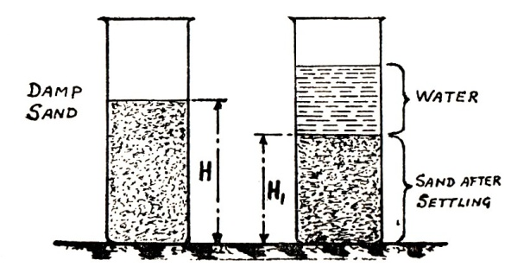

**Sand bulking test**

1. **Test for moisture content: It is similar to bunking test.**
2. **COARSE AGGREGATE TEST**

**The term coarse aggregate apply to the hard or solid materials which form part of the ingredients for making concrete such as gravel, crushed granites, shingle, broken bricks etc.**

**For concrete work of importance, clean washed peat gravel and crushed granite should be used. All aggregates must be free from clay and splits and must be angular. The test carried out on coarse aggregate are: i) Hardness, ii) absorption.**

**WATER:**

**Water is used to effect the chemical action in the cement known as hydration.**

**Hydration is the chemical reaction that takes place when water is added to concrete. This is due to the presence of gypsum. It is the action that makes the cement to set and harden.**

**For the purpose of hydration, only clean and drinkable water must be used to mix concrete ingredients.**

**The quality of water to be used for various mixes is controlled by water-cement ratio.**

**W.C =weight of water in a mix/weight of cement in a mix, is known as water-cement ratio.**

**PROPORTION OF MATERIALS:**

**Proportioning or ratio of materials in a mix is the amount of sand to coarse aggregate and water used for each bag of cement{ volume of one bag of cement is 0.0283} For a small job, it is better to measure concrete ingredients by volume { volume**

**MIXING OF CONCRETE:**

**Mixing of concrete is the process of mixing concrete ingredients together to produce a workable mix. A workable mix is a concrete mixture that can be transported, placed and compacted to produce a durable concrete free from segregation and honey comb**

**There are two methods of mixing concrete:**

1. **Hand mixing**
2. **Machine mixing**
3. **Hand mixing: it is known as manual mixing. It is carried out on a hard concrete surface known as bunker or modes well jointed platform. The tools needed for hands mixing are water can, or buckets, shovels, head pans or gauge boxes.**

**PROCESS FOR MIXING**

**The required volume of sand is measured first on the bunker and spread with shovel. The required bag of cement is spread over the sand.**

**The sand and the cement are totally mixed together with shovel by the labourer till the dry mixture looks dry green or grey.**

**The required quantity of gravel measured and placed over the sand and cement spread over. Water is added, the mixture is properly mixed together with shovel to produce a wet concrete {green} only the required quantity of water should be added to produce a workable mix.**

1. **Mechanical mixing:**

**This is known as mechanical mixing. These methods make use of concrete mixers of various types such as**

1. **Tinting drum mixers**
2. **Non-tinting drum mixers**
3. **Tractor mounted concrete mixers**
4. **Central plant {continuous } mixer**
5. **Tinting drum mixers: It has a single compartment drum with one opening and rotating on an inclined axis.**
6. **Non- tinting drum mixers: It has a single compartment drum having two openings and rotating on an horizontal a six**
7. **Tractor mounted concrete mixers: It has a single compartment drum with one opening. This mixer is mounted on a driven tractor.**

**The entire mixer has steep blades inside the drum that mix the concrete ingredient when it rotates as the engine is put on.**

**To add cement or sand adhering to drum of the mixer, little water is first put inside the drum followed by cement sand gravel and the remaining required water.**

**The mixing time recommended must be observed in machine mixing.**

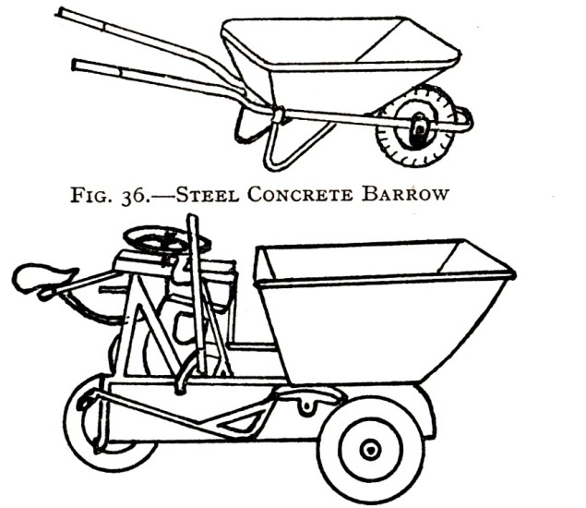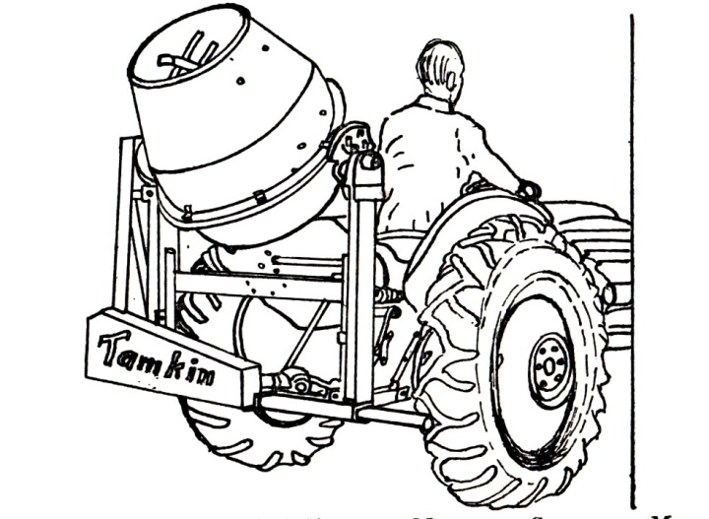

**TESTS ON CONCRETE**

**Tests are carried out on fresh concrete and harden concrete to determine**

1. **Water content in a wet concrete**
2. **Workability of the concrete**
3. **Strength of a hardened concrete**
4. **Slump test:**

* **A slump test verifies the consistency of concrete,**
* **Slump is a measurement of concrete’s workability, or fluidity**
* **It’s an indirect measurement of concrete’s quality.**
* **It’s a measurement for consistency, both from a quality-control perspective and to determine how fluid or stiff a material is.**
* **Slump is a test for the rigidity of uncured concrete. Lower slump concrete is very stiff, and higher slump concrete is more fluid.**

**The water content {amount of quantity} of water in a wet concrete can be compared and controlled by making slump test. The test is carried out when the concrete is fresh or green during mixing.**

**The apparatus needed are; [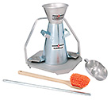](http://www.humboldtmfg.com/images/products/large/H-3635.jpg)**

1. **Slump cone**
2. **Priming/ Tamping rod**
3. **Slump plate**
4. **The measuring ruler**
5. **Scoop {a tool like a large spoon with a deep bowl, used for picking up substances}.**

**Method of carrying out the test:**

**The cone is placed on a hard surface or floor. It is filled with the concrete in four stages with the wet concrete.**

**At each stage, the concrete is compacted with the priming rod 25 times. At the final stage the surface is leveled.**

**The cone mould is immediately lifted vertically and placed inverted beside the concrete which has settled or slumped depending on the meters of the mix.**

**The amount of slump or settlement is measured in millimeter and is known as the slump. The test is carried on three mixes with different amount of water.**

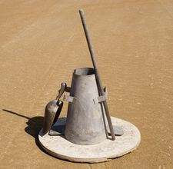

**TYPES OF SLUMP**

1. **True slump: this is a slump with good amount of water content in the mix**
2. **Share slump: it has inadequate water in the mix**
3. **Collapse slump: has too many water in the mix.**

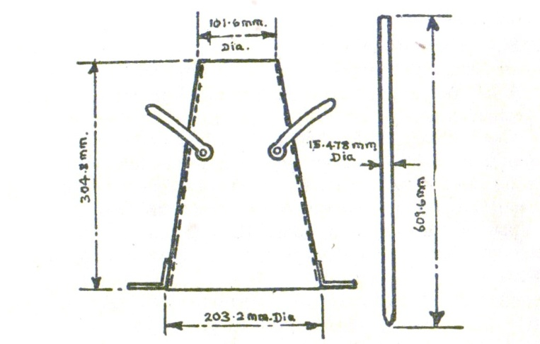

**Slum cone and pruning rod**

**Shear slump**

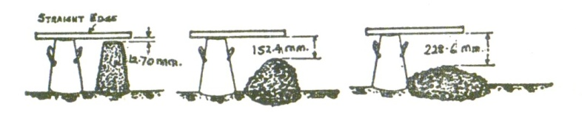

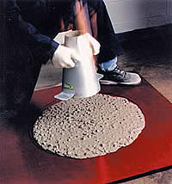 **collasp slum**

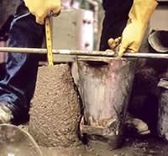 **True slump** 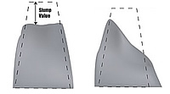

**The use of admixtures: ‘fix the mix’, they are designed to restore loads of concrete that might otherwise be rejected and to improve the performance of problem concrete by modifying its characteristics and enhancing workability.**

**Advantages of admixtures:**

1. **To ensure the best finished project**
2. **To slow down the set of concrete or accelerate**
3. **Temporarily makes concrete more fluid, allowing integral colour to disperse much better**
4. **Improve the strength**
5. **Reduce bleed water, resulting in fewer shrinkage cracks and more evenly coloured surface**
6. **Improves cohesiveness and reduces concrete segregation**
7. **Allows for the option of adding less water, creating a stronger concrete overall**
8. **They can fix concrete that is not quite what you ordered and they also can fill in when crew is shorthanded or limited.**

**CUBE TEST {Compression test}**

**The commonest test on hardened concrete is cube test. The test is carried out for the fact that concrete is weak in tension but very strong in compression. Concrete cubes are tested for their compression strength to improve on the tension, reinforcement bars are introduced to concrete at the base.**

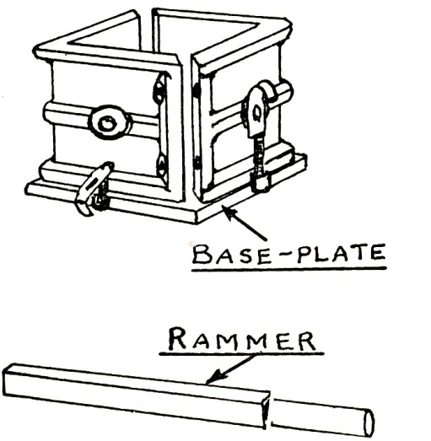 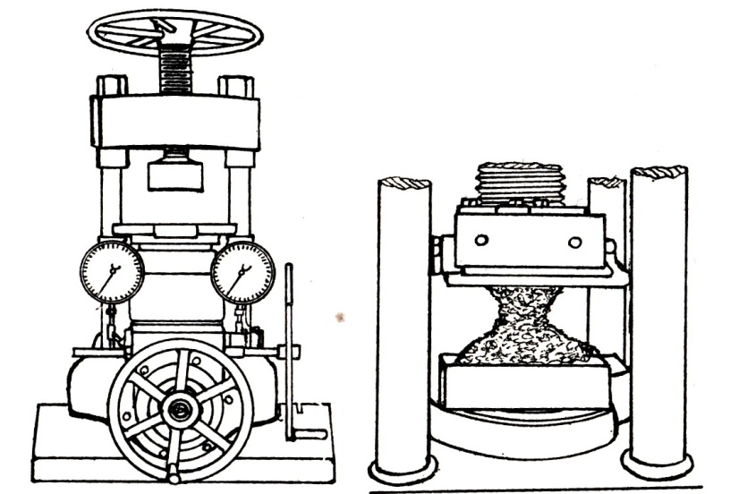

**Cube mould-box and rammer compression testing machine for cubes & enlarged view showing pyramidal fracture of a cubes**

**To perform the compression test, an iron mould-box of cubical shape is used to cast the specimen. It is usual to cast three samples at a time. One is being tested in three days, another 7 days or 21 days, 28 days.**

**The crushing strength at each day is recorded.**

**To carry out the test, concrete sample is taken from the mix and placed inside the mould in three layers. Each layer is well rammed or compacted with steel ramming bar. After 24 hours the cubes are removed from the moulds and stored in a water tank till it will be tested.**

**They are tested on their sides in a compression- testing machine making sure the cube breaks and the reading are recorded.**

**This test is used for mix design.**